**HomeQuest** is a real estate mobile app to simplify the process of finding and buying/renting Home, Office, Warehouse, factory etc. , enhance the user experience in property search and facilitate seamless communication between buyers and sellers and agents.

The primary goal and objective of HomeQuest is to provide revolutionize way to search property with various type of filter and sorting method with all details in grid and map view. Map View with appropriate filter will narrow down the user search in an interactive way.

User can choose their preferences based on location, price range, property type, amenities and with high resolution images library and virtual property tour will provide users an immersive experience.

By streamlining the property search process, we intend to save user valuable time and effort by ensuring they can find their dream property without any hassle.

Users can have two-way communication with prospective buyer or seller with our inbuilt messengers and can connect with appropriate agents for more help.

With all accurate and updated information with interactive user interface our real estate mobile app aims to making property search and buying experience more convenient, efficient, and transparent.

Features of HomeQuest Mobile app are:

1. Property Search:

Users can search properties based on location, price range, property type, amenities, etc. also provide advanced search filters for more specific preferences.

1. Property Listings:

Display detailed property information as listing like property area, rent/sale price, amenities, photos, virtual tours, floor plans, and descriptions, address. Include interactive maps to showcase property locations.

1. Saved Searches:

Save users search history to resume their search in any point of time.

1. Favourite Property:

Enable user to save shortlisted properties.

1. Notifications:

Enable push notification based on user search history and favourite property to update status changes of property like sold, available, for auction date etc.

1. Mortgage Calculator:

User can calculate best mortgage rate based on down payment, bank interested and load duration etc.

1. User Profiles:

Allow users to create profiles to save their contact detail for communication, search history, favourite property and manage their property inquiries and communications.

1. In-App Messaging:

Inbuild messenger will help user to stablish direct communication between buyers, sellers, and real estate agents.

This can be extended to schedule viewing, meeting and negotiating delas on the app.

1. Virtual Property Tours:

Incorporate virtual reality (VR) or augmented reality (AR) technology to provide immersive virtual property tours, users can explore properties remotely and get virtual site visit experience.

1. Feedback, Reviews and Ratings:

With feedback feature, user can identify top real estate agents nearby and by reviewing and ratings user can highlight the property condition and buyer/seller credibility.

1. Social Sharing:

With social sharing feature, user can share property details with their friends and family.

1. Real Estate Agent Directory:

User can search nearby trusted real estate agents with their profile and contact information to get connect with professionals for guidance and assistance.

**Market Research:**

In current marketplace we have a lot of competitors like Tommy’s Real Estate Limited, Harcourts Real Estate Wellington New Zealand, Lowe & Co Realty, Ray White, ONE AGENCY, Team YIP.

Most of our competitors are real estate agents and works for client-based directory. They normally manage and facilitate their client’s property. That will provide a limited options for the customers when they approach them. Also, most of the agents have old fashioned static website and for dynamic website they don’t have much updated information, they focus on face-to-face meetings to close the deals with those limited options.

Our focus is to provide a wide range of options to our customers by catering agents and owners property both with current market price trends. By considering that comparison and analysis is the best tool for layman to search property. Our inbuild price trend feature can help user to get approximate valuation of property as per the market.

With Virtual property tour, user can shortlist various and almost all property before going to actual site inspection. With all detail about the property and surrounding and virtual tour and in house contacts for more help like property agents, inspection services, documentation services, tax services. User can make their choice with peace of mind.

For the target audience, app is universal and can be developed for any region, state, country, user type for residential or commercial. But for the start we are focusing on residential property in New Zealand.

As per statCounter (<https://gs.statcounter.com/os-market-share/mobile/new-zealand>) in 2022-2023, new Zealand 51.35 % users are Android user and 47.6% user are iOS users. It is more effective to create mobile app for both platforms. Cross platform application is more suitable as the feature and requirement can be cater in there and application can be development faster for both platforms.

**Figma link for wireframe:**

<https://www.figma.com/file/Y3coEmAbu8UBQKISQBUCmJ/Assignment2_AdvanceMobileDevelopment?type=design&node-id=0-1&mode=design&t=JhKmCiskYjmaHkMN-0>

**GitHub Link:**

<https://github.com/vijend795/homeQuest.git>

**Login Credential:**

Username: [test@gmail.com](mailto:test@gmail.com)

Password: test123

**Screen Shot for actual Mobile App**

**Main Page Map View**

**Main Page Grid View**

**Screen Shot for actual Mobile App**

**Detail Property Part 2**

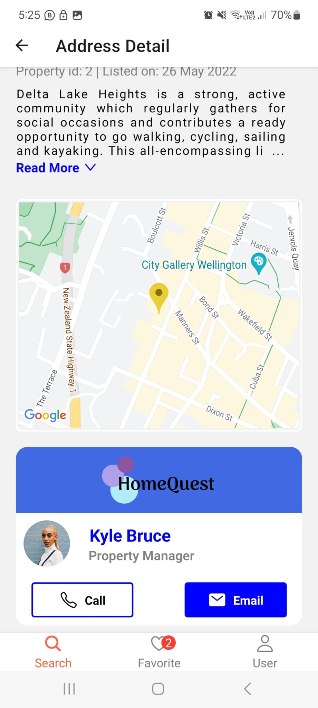

**Detail Property Part 1**

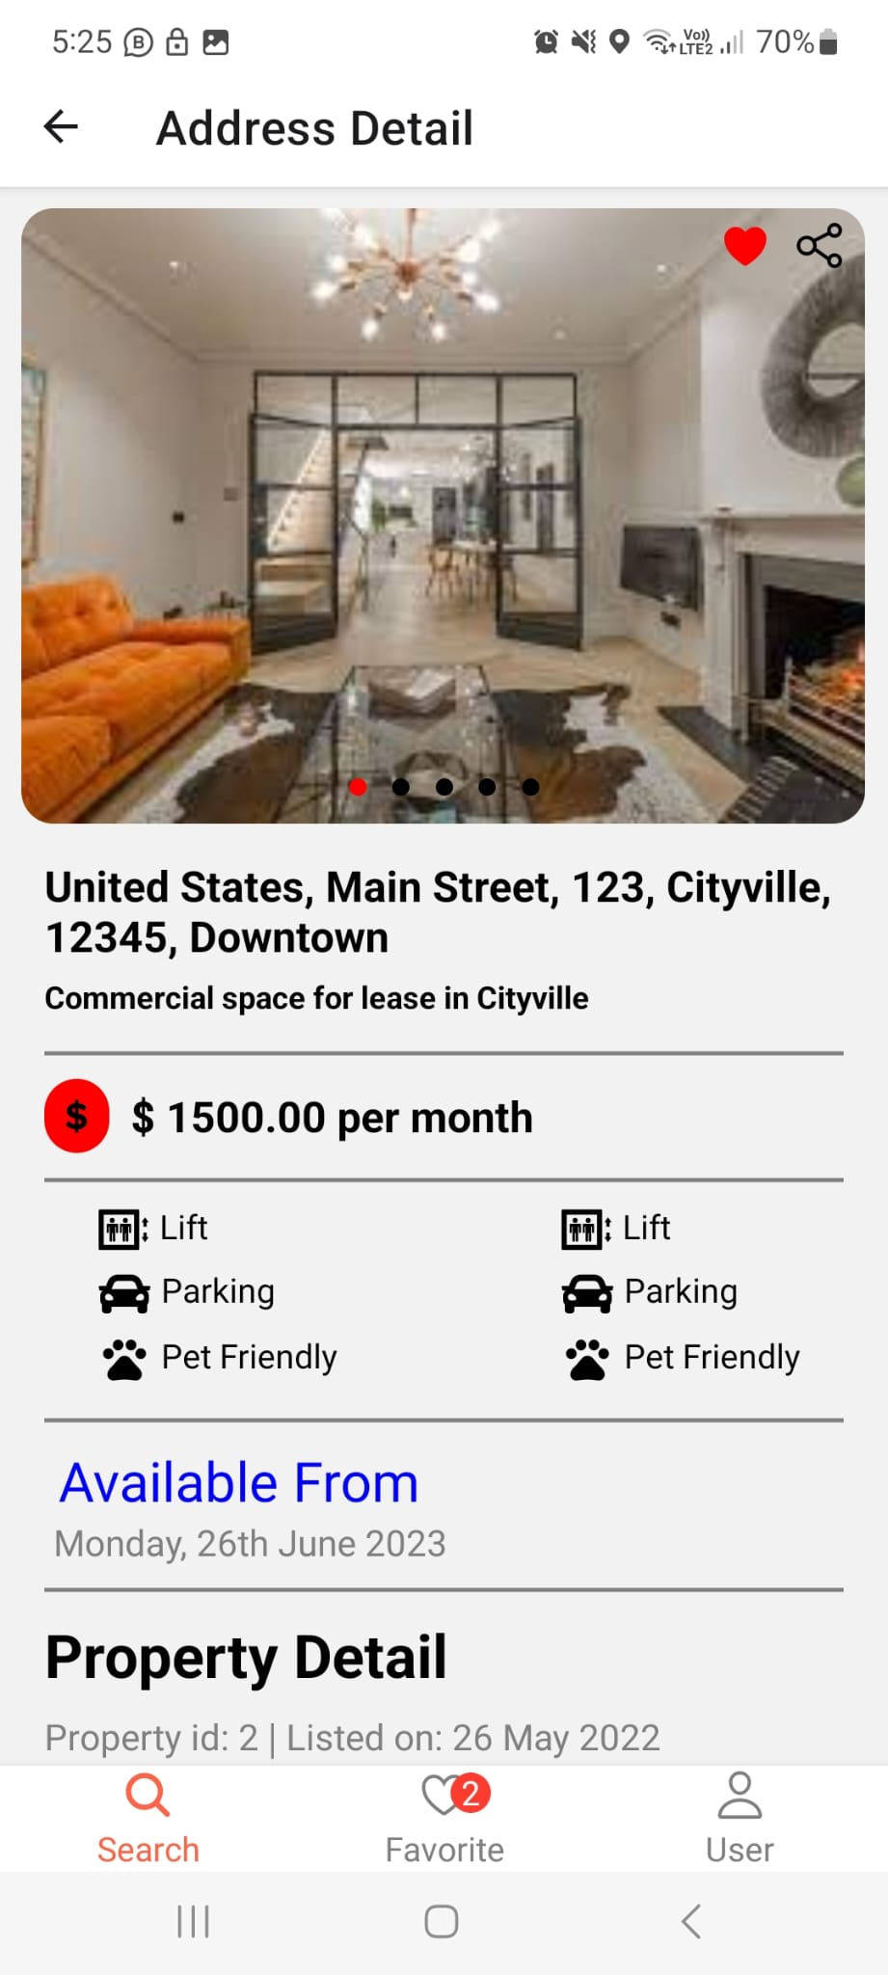

**Screen Shot for actual Mobile App**

**Last Login Page**

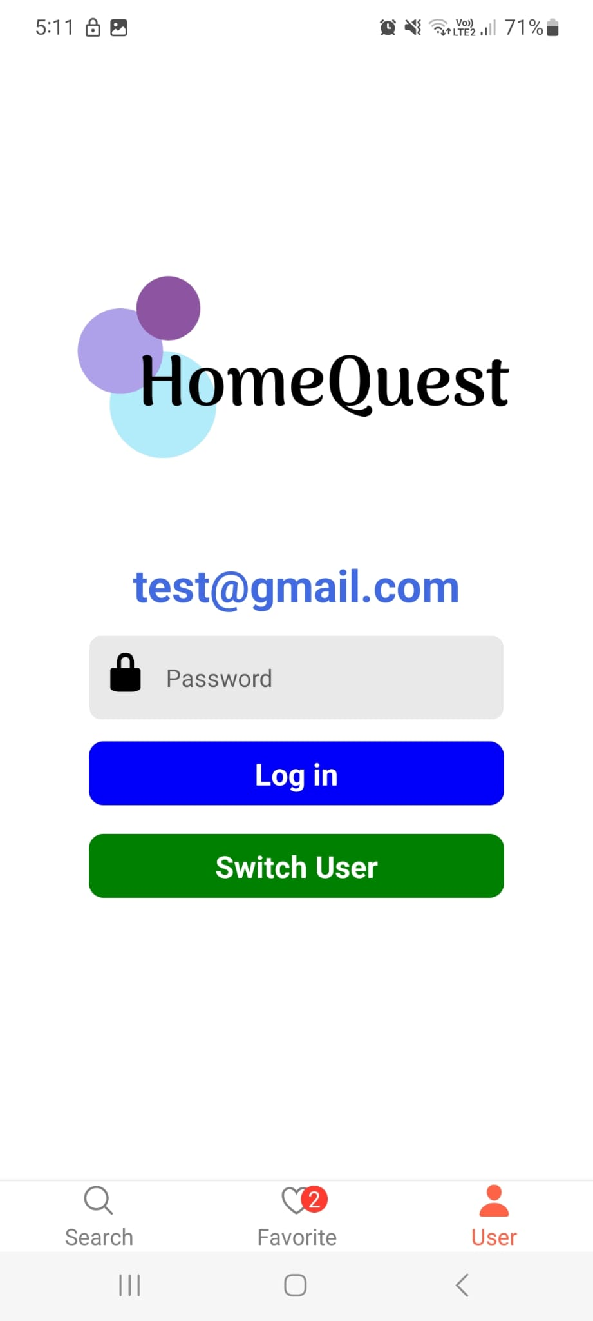

**Login Page**

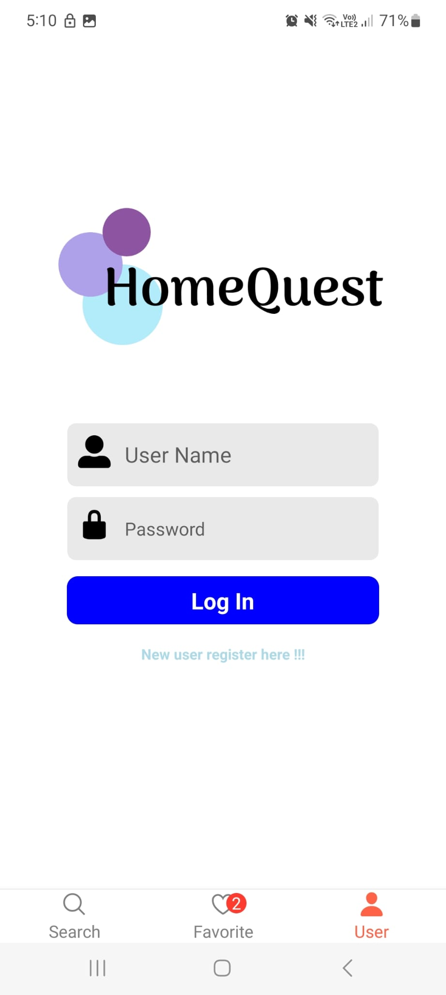

**Testing Application- Samsung s21**

Image 2

Image 1

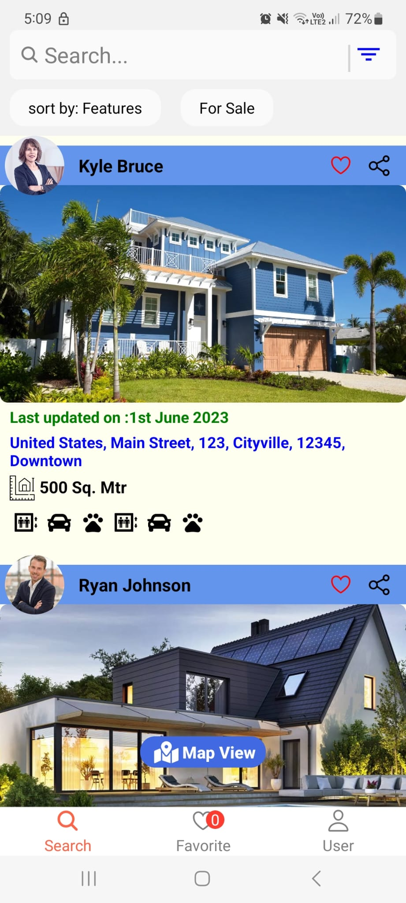

Image 4

Image 3

**Testing Application- Emulator :Pixel 6 Pro**

Image 2

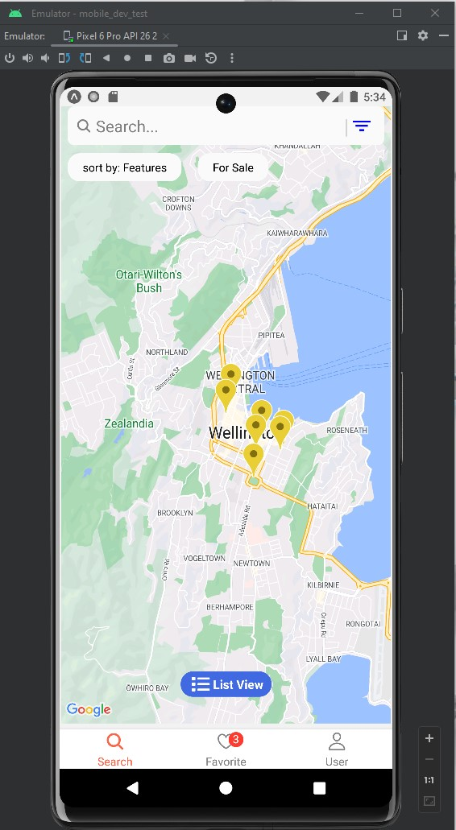

Image 1

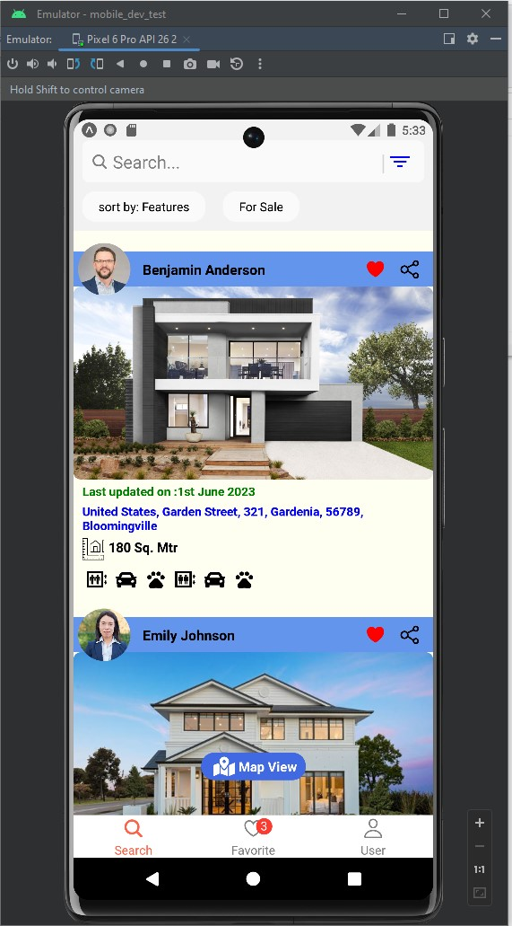

Image 4

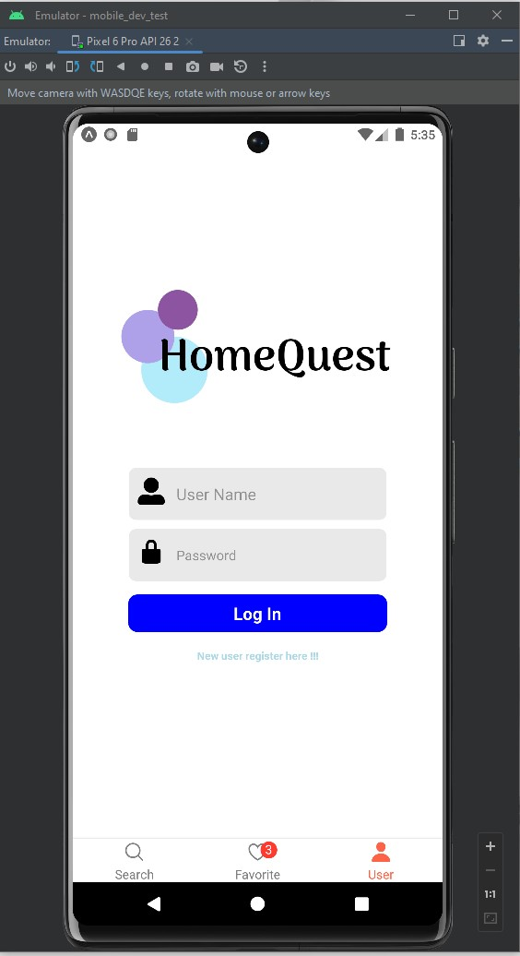

Image 3

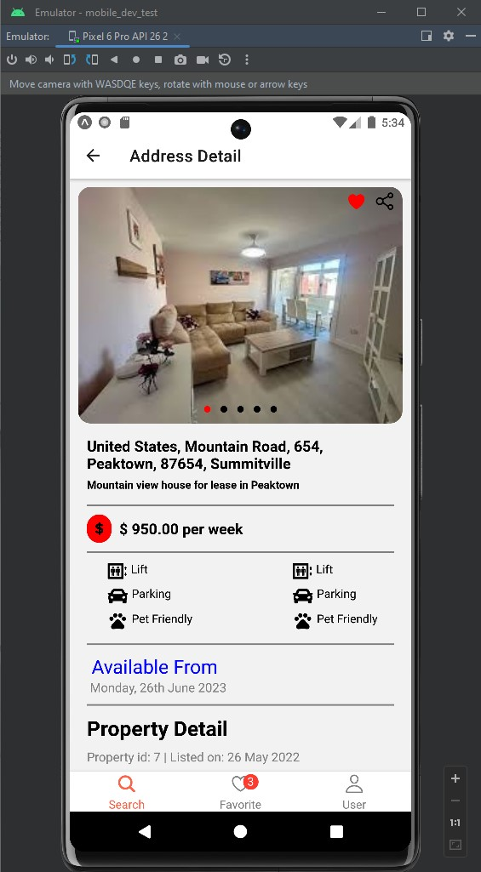

**Testing Application- iPhone 13**

Image 2

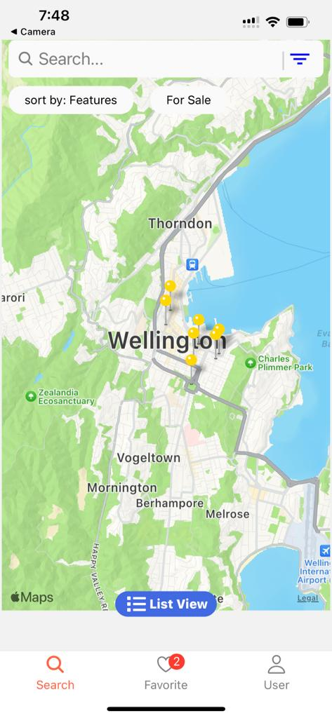

Image 1

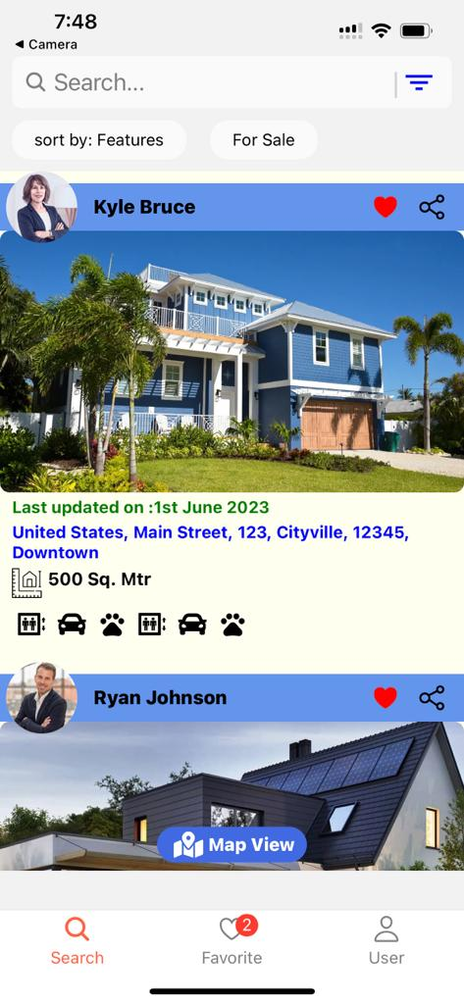

Image 4

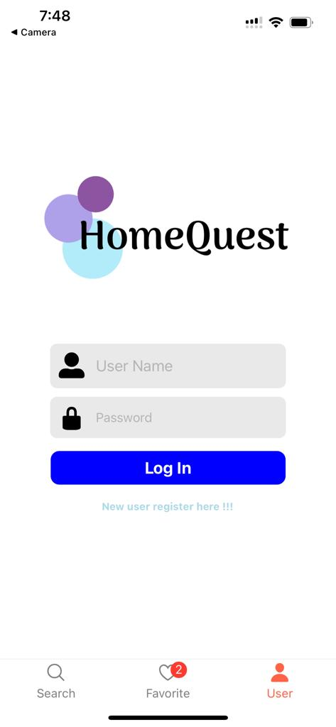

Image 3

